Student tasks
You will need to work on your own for the first two activities

- Spend a few minutes looking very carefully at the black and white aerial photograph below. The street labelled ‘A’ in red is Magdala Street.
- Make a list of ten key words of phrases to describe the geography in the image.
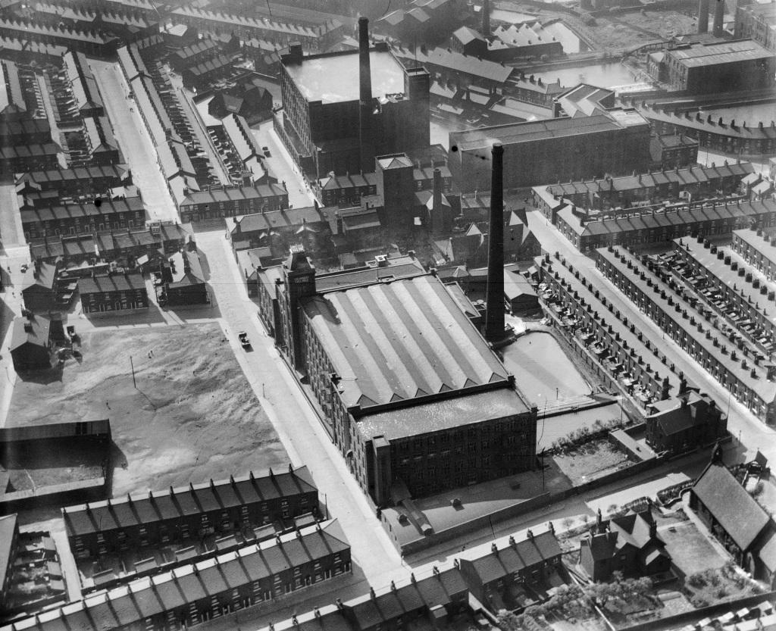
A

© Britain from Above & English Heritage – used with permission
http://www.britainfromabove.org.uk/image/epw050225?search=%20EPW050225&ref=0
You will now need to work in a pair for the following activities.

- Discuss the aerial photograph and your key words and/or phrases with your partner.
- Use the image to answer the following questions in your pair:
Where was the aerial photograph was taken?
When was the aerial photograph was taken?
What do you think the large building is?
Who might have worked there?
How do you think the area might look today?
Why do you think this might be?
Study the Google earth satellite image below for a few minutes. This shows a modern view of the same location as the previous black and white aerial photograph. The red label shows the location of Magdala Street.
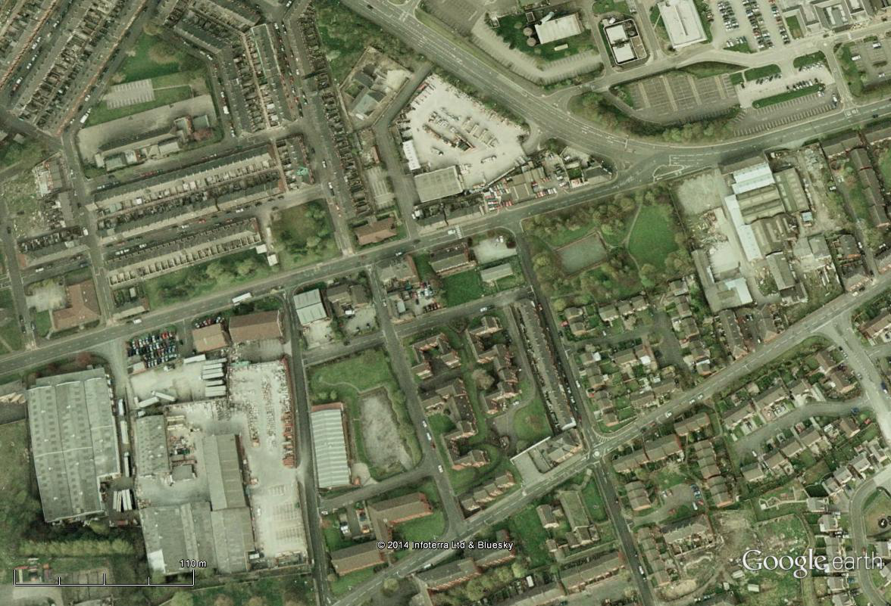
A

- With your partner, identify the physical (natural) and human (people-made) features shown on either the Google earth satellite image or the map.

Extension tasks
- Compare the black and white aerial photograph taken in 1936 with the Google earth satellite image taken recently.
- What differences in the geography of the area, can you see between the aerial photograph and the satellite image?
- What similarities in the geography of the area, can you see between the aerial photograph and the satellite image?
- Record your findings in a table, similar to the one below:

Similarities | Differences

- How do you think local people feel about the changes that have taken place since the aerial photograph was taken ?
- Who do you think might have been opposed to such changes?
- Who do you think might have approved of such changes?
- Do you think such changes have had a positive or negative impact on the area in question?
- Be prepared to share your findings with the rest of the class.

Teaching notes
This 1936 aerial photograph shows the Coldhurst Hall Cotton Mill,
located on Magdala Street in Oldham, Greater Manchester.
© Britain from Above & English Heritage – used with permission
http://www.britainfromabove.org.uk/image/epw050225?search=%20EPW050225&ref=0
Oldham initially missed the earliest growth period of the Industrial Revolution, as the climate, geology, and topography of the area were major disadvantages. Hatting, coal mining and the woollen trade provided the main income for the inhabitants of Oldham and its surrounding rural areas until the 1770s.
The first cotton mill opened in 1778 and cotton spinning and milling began a spiralling process of urbanisation and socioeconomic change, which transformed Oldham from a small town into a major industrial centre.
Oldham continued to prosper and grow and became the world's manufacturing centre for cotton spinning in the second half of the 19th century. There was a corresponding population increase from just over 12,000 in 1801 to 137,000 in 1901. In 1851, the census recorded more than 30% of Oldham's population employed within the textile sector, compared to 5% across Great Britain.
At its peak, Oldham was the most productive cotton spinning mill town in the world with over 360 mills, operating night and day, with more spindles than any country in the world except the United States. The industry continued to prosper until the First World War and the UK's largest textile factory, Elk Mill was then built there in 1928. Oldham's cotton industry however, declined throughout the twentieth century, and the last cotton was spun in the town in 1998.
The future for cotton in Oldham may yet hold a surprise as the Manchester Evening News reported in November 2012, http://archive.is/YPYpk on plans to revive the local textile industry.

